Minutes for Mills Haven School Council

Call to Order
A School Council meeting of Mills Haven Elementary was held on March 13th, 2018 at Mills Haven Elementary Library. It began at 6:00pm and was presided over by Becky M. School Council Secretary, with board member Tanya O, Grade 3 Representative taking the minutes.

Attendees

Becky M.
Jodi S.
Marlis M
Sarah G
Sabine S
Sivanthy S
Conny F.
Garry R
Rob B
Sherry J
Tanya O
Erin Fisher
Sue A

Approval of Minutes
CHANGES: Change date on minutes
A motion to approve the minutes of the previous February 13th, 2017 meeting was made by Sivanthy S and seconded by Tanya O

Additions to the Agenda
- none

School Report
Garry provided school report
  - PALS moving to Pine Street School.
    - Possible new space for parent room
  - Edmonton Opera
    - Great presentation, students loved it.
  - Speech Competition on Thursday, March 15
  - Report Card out on Monday, March 19
  - New Registration Process
    - Parents can log into Power school to register their children for the following year
    - End March 15
  - Central office going to a standardized supply list
    - Mills Haven teachers
  - Christmas Concert Meeting Update
    - Possibly move to new location: Salisbury High School
    - Evening performance only
    - Discussion about other locations, community centers etc.

School Trustee Report
Not Present

Treasurers Report
- Account Balance (end of November): $4601.39 remains to continue paying the 2017/18 commitments.

- Ski trip bussing may still have to ne paid. Waiting on EIPS Central Office to approve or deny parent payment of $2 per student.
Becky M. accepts this Treasurer’s Report.

GBA Report
- Commitments will be lower next year due to EIPS paying for promotions
- Outgrown it sale end of April
- Bottle Drive in May-Joint Fundraiser with School Council

Chair Report
Chair Report was presented by the Secretary, Becky M
- Open School Council Chair Position
- Becky Mitchell, School Council Secretary, asked the minutes to show that Stacey LeClaire stepped down as MHV School Council and MHSSES Chair on January 16, 2018.
With the Chair position open, Sherry Jones, a Mills Haven Parent in attendance at the meeting, has presented her interest in filling the MHV School Council and MHSSES Chair positions.
Becky M accepted Sherry J’s request for the Chair positions and asked if any members present are opposed or wanted the opportunity to run for the Chair positions.
No other present members are opposed or running for Chair position.
Sue Angell seconded Becky Mitchell’s acceptance of Sherry Jones’ Chair position.
VOTE RESULT: All members are in favor.
As of March 13, 2018 at 6:15pm, the new MHV School Council and MHSSES, Chair is Sherry Jones. Sherry will take on shared signing authority for MHV School Council, MHSSES and MHV Casino Accounts.
- All members welcome Sherry to Council.

- Kindergarten Senior Home Visits-Funding needed
  - Funding and grants are still needed
  - Becky M asked any info to be emailed to the school
- Summer Sizzler- CANCELLED
- No volunteers to lead event
- Email update will be sent home to families
- Possible Educational Item Purchase Presentation
- Jodi S presented Orbits- mini robots programed by markers.
- Would be a division 1 learning tool-beginner coding
- Jodi S will look into pricing
Open Discussion for new initiatives and ideas:
- Possible Educational Item Purchase Presentation
- Jodi S presented Orbits- mini robots programed by markers.
- Would be a division 1 learning tool-beginner coding
- Jodi S will look into pricing
Becky M. moved that the meeting be adjourned, and this was agreed upon at 6:35pm.
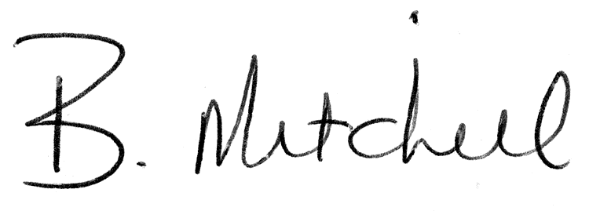 |  | Tuesday, March 13, 2018
Secretary  Mills Haven School Council |  | Date of Approval

