Minutes for Mills Haven School and Student Enhancement Society

Call to Order
An MHSSES Council meeting of Mills Haven Elementary was held on April 10th, 2018 at Mills Haven Elementary Library. It began at 6:01pm and was presided over by Sherry J. School Council Chair, with School Council Secretary, Becky M taking the minutes.
Attendees
Becky M.
Sherry J
Marlis M
Anna M
Ali S
Lisa H
Sarah G
Sivanthy S
Tanya L
Erin F
Garry R
Chandra C
Sabine S
Brandy C

Approval of Minutes
A motion to approve the minutes of the previous March 13th , 2018 meeting was made by Sivanthy S and seconded by Sherry J

Addition to Agenda
- None
School Report
- Rocks & Rings: Will be booked to come in before the end of the year. $220 out of School Council Cultural Performance fund to be used.
- Purchased 15 new soccer balls for classroom-School Council supported this cost
- 4year Education Plan
  - Maintaining Numeracy and literacy
  - ----
  - Character Building: will be following the 7 traits of FNMI
- Christmas Concert: looked into using Salisbury Composite High in stead of church. Staff decided to stay with church for 2018 but to only do an evening performance. No daytime rehearsal and performance. No bussing costs.
- FNMI- funding approved to hire 1 teachers for 7 blocks per week and purchase educational videos.
- ESO- Booked for 2018/19. School Council will pay for student tickets. Bussing costs will be paid for individually by student through school fees.
- Hot Lunch-Kindergartens will not be a part of hot lunch for 2018/19
- School Fees are finalized
- Teacher position posted-Irene Kolomijchuk retiring
- Sal Comp Drum Production- April 20. Paid for by school Council through Cultural performance funds
- Fire, Lockdown, hold and Secure Drills begin done throughout the spring.
- RCMP Horses visiting again soon.
- Library Renos: Vendors have been in for design quotes.
- Current School Population for 2018/19: 467 Students
School Trustee Report
- Board Highlights:
  - Trustees are currently doing school tours around the district.
- Alberta School Board
  - Policies are in review
  - Reporting on Student Achievement
    - Voted to continue current practices. Eg. number grades at elementary level and percentage grade at higher levels.
- 3Year Capital Plan
  - 3 priorities
    - Modernization of Sherwood Heights
    - Modernization of Rudolph Hennig
    - Cluster study of other schools for modernization.
  - No priorities will be funded by the Alberta government next year.

Treasurers Report
Treasurer’s Report was presented by Becky M.

Account updates:
- Casino Account: Currently $371.89
- Fundraising Account: End of March $21,004.89
This Treasurer’s Report was simply read by Becky M and will be confirmed and expanded upon by Jodi S. in the May school council meeting. Report was not accepted by any members.

Chair Reports

Presented by Sherry J, Chair

- New Playground Update:
  - No contact from Strathcona County as of April 10.

Update on Email Voting
  - No email votes in March/April
- Hot Lunch:
- Everything is going really well. No issues
- Looking into vendors for next year that will comply with nutrition guidelines.

Milk:
- Program is going well.

- Panago Fundraiser
    - $1000 was raised.
    - Thank you to Sue Angell and Sivanthy Suntharalingam for running this fundraiser.
    - Mrs. DaCosta’s Grade one pizza party will be on Thursday, April 26.
    - Will have final fundraiser total once all expenses are submitted

- Spring Bottle Drive
- May 26, 2018
  - 6 volunteers needed

- Family Movie Night
    - Stacey L is running Family Movie Night on April 13.

- Carnival Concession
    - The school is planning to do Carnival again this year.
    - Concession will be discussed. Tanya L will do the shopping

Discussion: Fundraising for2018/19
- School and GBA both presented their budget and commitment needs for 2018/19 school year.
School Council: $9700 GBA: $8000-$9000
- A Lengthy Discussion was had about the how the two fundraising groups in the school would work together. Both groups discussed the strain the amount of fundraising in the school puts on our families. It was agreed upon to keep the fundraising to a minimum, be well scheduled and organized.
- Different types of fundraisers were discussed by each group.
- Joint fundraisers
Keep: Fall/Spring Bottle Drives. New ideas: Sign Night in Gym, Student Art Walk
- GBA Fundraiser ideas Projected Earnings:
- Stawnichy’s $1800-$2600, Apples (unknown), Bottle Drives $1000, Pretzel Days(1) $750
School Council Fundraiser ideas Projected earnings:
- Write-On Supplies $600-$1000, Bottle Drives $1000, popcorn Day $500, Hot Lunch $5000, *still need one large fundraiser with projected earning of $3000-$5000
- School Council will discuss which fundraiser they would like to go with for 2018/19 over email and announce at May meeting.

- School Council Community Events for 2018/19: Family Movie Night, School Dance, Winter Play Day
GBA School wide Cultural events for 2018/19: Oktoberfest, St. Nicholas Tag

- Fundraiser/Events for 2017-2018 (Volunteers and leaders)
- May Volunteer list/fundraisers
- May 26 Bottle Drive: Volunteers needed

- Carnival (school run event) Volunteers needed to run concession
- Tanya L shopping
- Becky M- volunteers

School Council Chair asked if anyone had anything to add to the MHSSES meeting.
No members had anything to add.

Announcements
Next MHSC & MHSSES Meetings will be held on Monday, May 7th, 2018. At 6:00pm in the school library.

Adjournment
Sherry J moved that the meeting be adjourned, and this was agreed upon at 7:40pm.

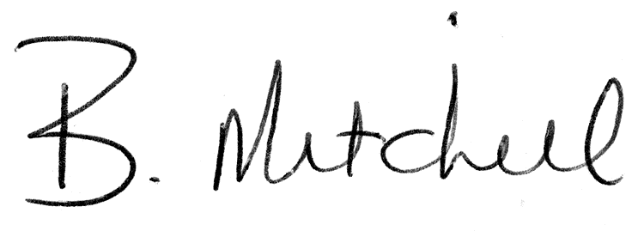
Secretary  Mills Haven School and Student Enhancement Society |  | Date of Approval

