Minutes for Mills Haven School Council

Call to Order
A School Council meeting of Mills Haven Elementary was held on May 7th, 2018 at Mills Haven Elementary Library. It began at 6:06pm and was presided over by Sherry J School Council Chair, with Becky M School Council Secretary taking the minutes.

Attendees

Becky M.
Jodi S.
Marlis M
Sivanthy S
Garry R
Sherry J
Tanya L
Sivanthy Suntharalingam
Anna M

Approval of Minutes
No Changes
A motion to approve the minutes of the previous April 10th, 2017 meeting was made by Anna M and seconded by Sherry S

Additions to the Agenda
- None

School Report
Garry provided school report
  - 2018/19 events
    - Rocks and Rings October 22-23 $480 paid for by School Council
    - December 13 evening concert: Council will organize collection
  - Asphalt in front will be worked on to fix drainage. New sign will be put on gym.
  - Library Update: All new furniture has been ordered, should arrive end of June.
  - Parent Room
    - Parents will have use of the laminating room for hot lunch and other supplies.
    - Use of old PALS room will also be provided for use.
  - New Staff
    - Posting new Gr 2 and Kindergarten Teacher positions
  - Carnival
    - Volunteers needed to sell tickets in the morning and run concession
    - School Council donates concession items
  - Art Exhibit: teachers approved the idea
  - 2 tether balls have been ordered from remaining school council recess fund.
  - New Staff- Sarah Choo
  - Survey
    - Grade 4 parent survey
    - 66 parents responded
    - School was rated high overall with some concerns highlighted

School Trustee Report
Not Present

Treasurers Report
- Account Balance (end of April): $4228.00 remains to continue paying the 2017/18 commitments.

- $1000 remaining in ski trip money

- $1000 remaining in Cultural performance money

MOTION: Jodi S motioned to keep the extra ski trip money open for general school use.
Becky M seconded this motion.
Vote: All in Favor

Becky M. accepts this Treasurer’s Report.

GBA Report
Not Present

Chair Report
Chair Report was presented by Sherry M.
- Picture Day
  - 2 volunteers are needed to assist in class picture day.
  - Becky M and Tanya L volunteer

- Carnival Concession
- Volunteers are needed to help sell tickets in the morning, set up and clean up of concession and to run the concession throughout the afternoon.
  - Tanya L will do the shopping
  - Sherry and Becky will take of volunteers and info home
- Canada Day Celebration
- 2 parent volunteers are needed: Becky M and Sherry J volunteered
- For September school year start
  - Meet the teacher night, Sherry would like to have a school Council table set up with popcorn to meet parents.
Open Discussion for new initiatives and ideas:
- Lisa H. presented and possible Enbridge partnership.
- School can be selected to be a part of Enbridge’s free safety program
- Lisa will forward information
Sherry J. moved that the meeting be adjourned, and this was agreed upon at 6:43pm.
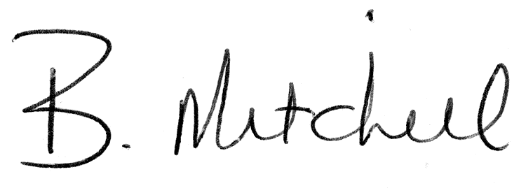
Secretary  Mills Haven School Council |  | Date of Approval

