Minutes for Mills Haven School and Student Enhancement Society

Call to Order
An MHSSES Council meeting of Mills Haven Elementary was held on Oct 10, 2018 at Mills Haven Elementary Library. It began at 7:04 and was presided over by Sherry J. School Council Chair, with School Council Secretary, Becky M taking the minutes.
Attendees
Becky M.
Keri B
Sivanthy S
Caleb V
Sherry J
Tanya L
Jodi S
Anna M
Meagan M

Approval of Minutes
A motion to approve the minutes of the previous September 11th ,2018 meeting was made by Anna M and seconded by Meagan D.

Addition to Agenda
- None

Treasurers Report
Treasurer’s Report is presented by Jodi S, Treasurer.
MHSSES End of September account balance: $21776.76
- Jodi stated that 2018/19 Commitment money transferred to the School Council account has not yet been reflected in September’s bank statement
Casino Account end of September balance: $18106.43
Becky M accepted the treasurer’s Report
- Jodi S. confirmed that the Treasurer’s Report read by Sherry J in MHSSES’ September meeting was written and submitted by herself. Jodi has read the MHSSES September minutes and approved the information, discussion and motions.
Becky M motioned to accept Jodi’s MHSSES September Treasurer Report. Tanya L and Anna M Seconded the motion.

Chair Reports
Presented by Sherry J, Chair
- Mom’s Pantry Fundraiser
    - Fundraiser will start Monday, October 15 and run until Wednesday, October 31st.
    - Volunteers will be needed for delivery date
    - It is agreed upon to have 3 pizza parties for the top selling classes and two prizes for the top two selling students.
    - Tanya and Anna volunteered to run pizza parties.

Update on Email Voting
No email votes in September
- Hot Lunch: Update by Becky M
    - Ready to start on Friday, October 12.
    - All volunteer positions were filled
    - Becky announced that this will be the last year for the current leadership committee. Becky, Sivanthy and Tanya will all be “retiring” from the program. Becky has gone back to work full time and can no longer put the time into the program needed. Between the 3 committee leaders at least one leader needs to be able to be in the school to oversee the program, inventory and volunteers. The Website Coordinator can completely work from home, but the label delivery Committee vendor also needs to have daytime hours available to drop off labels.
    - Information seeking a new committee will go out later in the year.

Milk:
- Program is going well.
- Milk helpers are needing some review. Karen will work with Mr. Peters to go over program again.
- Kindergartens are now receiving milk
- There have been some distribution issues. Hopefully that will smooth out soon

- Bottle Drive:
  - The joint School Council GBA Bottle Drive is this Saturday, September 15/18. More volunteers are needed.
  - Becky will send home flyer. Sherry will send out emails
- Christmas Concert Silver Bells Collection:
- School Council is no longer paying for the concert but will provide volunteers to the school for the collection this year.
- Volunteers will once again have first pick of their seats at concert.

School Council Volunteer needs for 2018/19
- Mom’s Pantry
  - Sherry J, Becky M, Tanya L

School Council Chair asked if anyone had anything to add to the MHSSES meeting.
No members had anything to add.

Announcements
The next MHSC & MHSSES Meetings Wednesday, November 21,2018 at 6:00pm in the school library.

Adjournment
Sherry J moved that the meeting be adjourned, and this was agreed upon at 6:50pm.

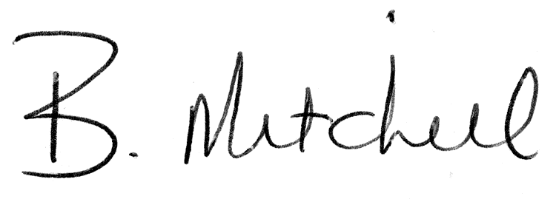
Secretary  Mills Haven School and Student Enhancement Society |  | Date of Approval

