Minutes for Mills Haven School Council

Call to Order
A School Council meeting of Mills Haven Elementary was held on October 10, 2018 at Mills Haven Elementary Library. It began at 6:05pm and was presided over by Sherry J School Council Chair, with Becky M School Council Secretary taking the minutes.

Attendees

Becky M.
Keri B
Sivanthy S
Connie F (GBA)
Sherry J
Tanya L
Anna M
Laura D GBA)
Sarah G (GBA_
Erin (GBA)
Rachel K
Anke E (GBA)
Becky M (GBA)
Michael S (GBA)
Chandra C (GBA)
Laura G (GBA)
Meagan D
Pia J (GBA)
Laura G (GBA)
Esra S (GBA)
Jodi S

Approval of Minutes
No Changes
A motion to approve the minutes of the previous September 11th, 2018 meeting was made by Tanya L and seconded by Chandra C

Additions to the Agenda
- None
New Year Introductions for everyone at the meeting

School Report
Keri B, Vice Principal, provided school report
  - Accountability Pillar
    - Review results are really great at Mills Haven Elementary
    - Results will be upon school website to view
  - Successes:
    - EIPS Consultants are working in the school with teachers for Math and Literacy.
  - New Curriculum
    - No timelines or deadlines as of yet. Will be signed off on in December and Legislated at that point
  - New EA hired in Kindergarten

  - Rocks and Rings
    - A Curling Canada program geared towards introducing elementary students to curling is coming into the school. This event has been paid for by School Council Parent Group.
  - Wee Read
    - Program geared towards Kindergarten -Grade 3 to help students find the love of reading. Volunteers are needed to come into the school to read to children. Volunteers DO NOT have to be parents.
    - There is a quick 15min training session.
    - School is asking School Council to help put call out for volunteers
    - Email Rachel Kihn at Rachel.kihn@eips.ca

School Trustee Report
Not Present

Treasurers Report
Treasurer’s Report is presented by Jodi S, Treasurer.
School Council End of September Account Balance: $1853.93
- Jodi stated that 2018/19 Commitment money had not yet shown up in the bank report.

- Jodi S. confirmed that the Treasurer’s Report read by Sherry J in School Council’s September meeting was written and submitted by herself. Jodi has read the School Council September minutes and approved the information, discussion and motions.
Becky M motioned to accept Jodi’s School Council September Treasurer Report. Tanya L and Anna M Seconded the motion.

GBA Report
- Sign Night Update
  - The company has created a webpage. Offering a PDF for distribution at a cost of $25
    - All present agreed that was a great price to have the flyers and info made up for us. It was agreed to go ahead and purchase the PDF
- Register online, choose sign(s) you would like to paint.
- Date Set for Friday, November 23/18. 6:30pm-9:30pm
- Talk of getting local restaurants such as David’s Tea to supply beverages.

Chair Report
Chair Report was presented by Sherry M.
- Library Book Fair
- School Council is assisting the librarian in getting volunteers for the book fair. More volunteers are needed for evening and daytime help
- School Council Position openings
  - Welcoming Caleb V has taken on Kindergarten Class Rep position
  - Grade 1 Rep, Grade 5 Rep
- Insurance for MHSSES
  - Sherry and Jodi will follow up
Open Discussion for new initiatives and ideas:
No new discussion or ideas.
Sherry J. moved that the meeting be adjourned, and this was agreed upon at 6:58pm.
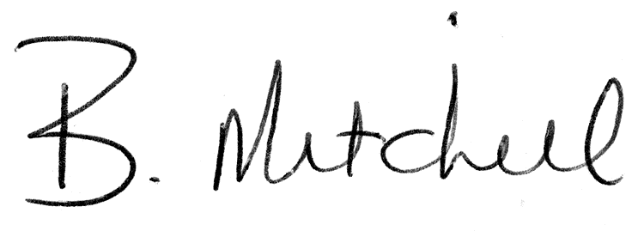
Secretary  Mills Haven School Council |  | Date of Approval

